**VIETNAM NATIONAL UNIVERSITY OF HO CHI MINH CITY**

**UNIVERSITY OF INFORMATION TECHNOLOGY**

**FACULTY OF COMPUTER ENGINEERING**



**FINAL PROJECT REPORT**

**IMAGE PROCESSING : FILTER FOR IMAGE**

**Lecturer: Trần Thị Điểm**

**NGUYỄN TUẤN DŨNG - 21520746**

Table of Contents

CHAPTER 1: GENERAL INTRODUCTION 3

1.1 Definition of image embossing 3

1.2 Design flow 3

1.3 Technical details 3

CHAPTER 2: THE STEPS TO IMPLEMENT THE SYSTEM 4

2.1 Working with pixels 4

CHAPTER 3: CONCLUSION 7

3.1 Result 7

3.2 Directions for future development 8

3.3 Directions for future development 8

# CHAPTER 1: GENERAL INTRODUCTION

1.1 What is image embossing?

Image embossing is a computer graphics technique in which each pixel of an image is replaced either by a highlight or a shadow. Low contrast areas are replaced by a gray background. The filtered image will represent the rate of color change at each location of the original image.

1.2 Design flow:

1.3 Technical detail:

To apply the embossing effect, a convolution operation is performed between the image and an embossing mask or kernel.

• Mask: The embossing mask is a matrix or a small filter that specifies how the pixels in the image should be adjusted to achieve the desired effect.

The emboss filter, also called a directional difference filter, will enhance edges in the direction of the selected convolution masks. When the emboss filter is applied, the filter matrix is in convolution calculation with the same square area on the original image.

A few basic masks:

Demonstration of convolution between the original image and kernel matrix:

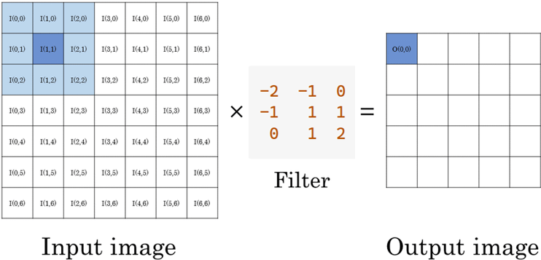

# CHAPTER 2: THE STEPS TO IMPLEMENTING THE SYSTEM

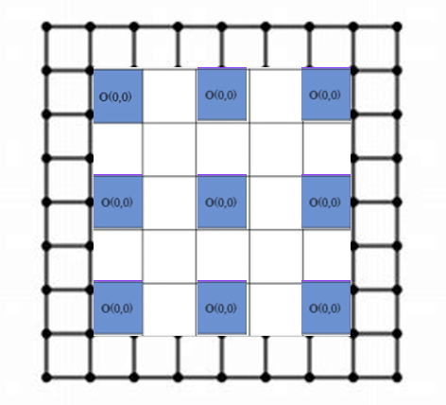2.1 Working with pixels:

Checking pixels in every position:

To emboss an image, we need different kernel matrices for different pixel of the image since the corner pixels and edge pixels have less neighboring pixels than those inside.

In this project, we make the embossing filter will enhance edges in diagonal direction from left to right and downward.

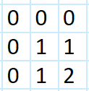Here is the mask for upper left corner pixel:

Verilog implementation of said matrix:

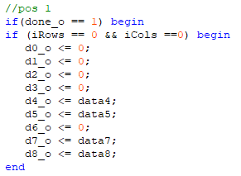

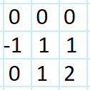For upper edge pixels:

Verilog implementation:

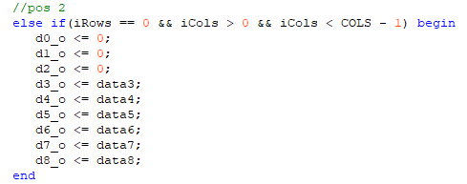

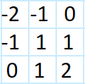For inside pixels:

Verilog implementation:

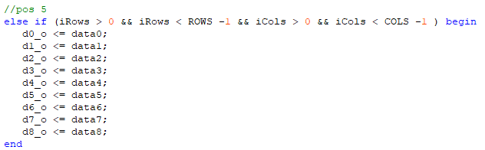

# CHAPTER 3: RESULTS & CONCLUSION:

3.1 Results after image emboss:

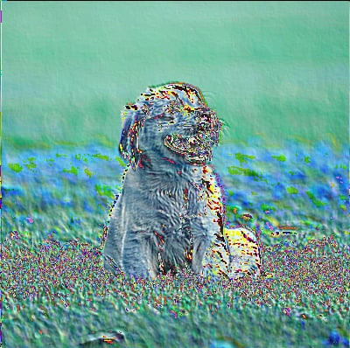

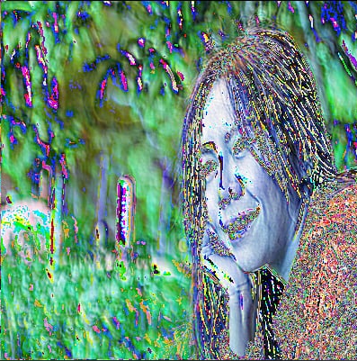

Original image Embossed image

3.2 Conclusion:

The image embossing project successfully demonstrated the implementation of digital embossing techniques using image processing algorithms. By converting 2D images into embossed visuals, we created a simulated 3D effect that enhances the texture and depth perception of the original images. This project encompassed various stages, including image preprocessing, gradient calculation, and the application of embossing filters.

3.3 Direction of development:

The image embossing project has laid a solid foundation in digital image processing, transforming 2D visuals into simulated 3D textures. As we look to the future, several promising directions for further development stand out.

Enhancing Realism and Detail is another priority. Extending techniques to support color images and capturing finer textures will produce high-fidelity embossed images, preserving color integrity and adding visual appeal. This requires advanced filtering and high-resolution processing.

_END OF DOCUMENT_